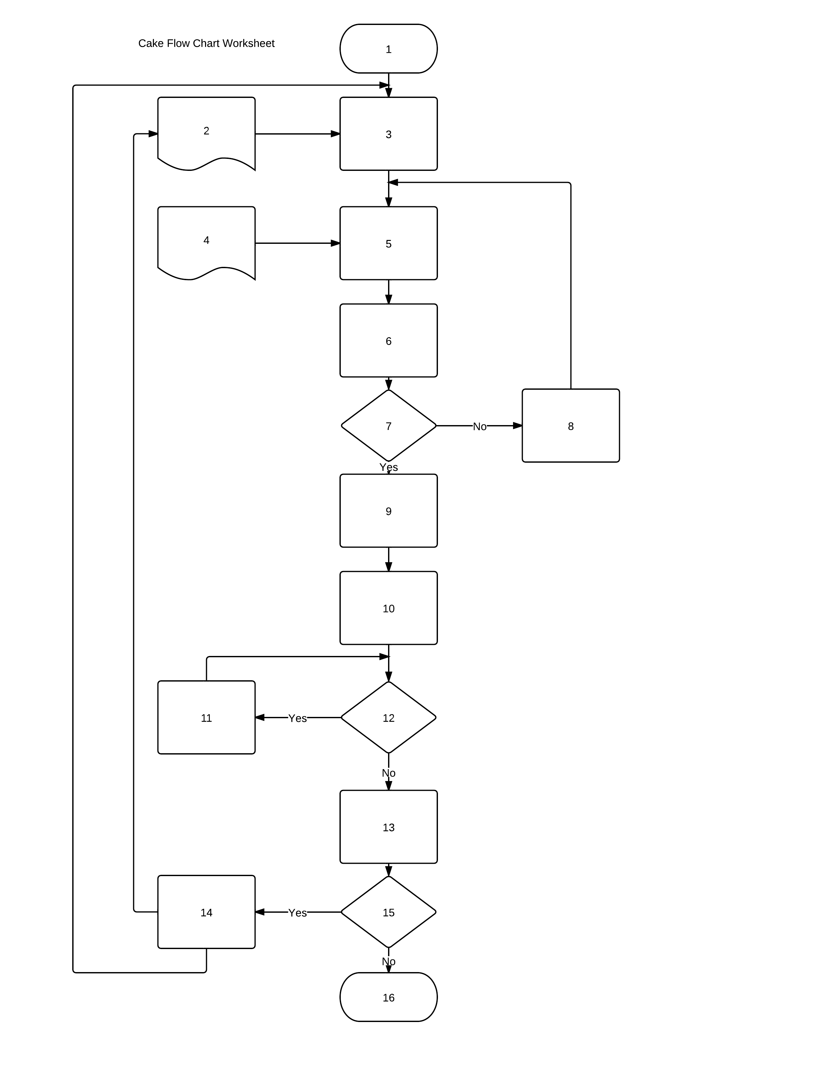
# | Content
 | Recipe
 | Eat Cake
 | Bake Cake
 | Want Cake
 | Get Recipe
 | If cake is bad
 | Go Shopping
 | Update Recipe
 | Add more liquid
 | Pantry Inventory
 | If difference is >=0
 | Get Pantry Inventory
 | Get Recipe Mix is dry
 | Combine Dry Ingredients
 | Incorporate wet ingredients into dry
 | Calculate Difference between Pantry Inventory and Recipe
NAME |  | PER

